**Analysis of Customer Behavior and Subscription Patterns at Foodie-Fi**

**Executive Summary**

This report provides a comprehensive analysis of customer behavior and subscription patterns at Foodie-Fi, a subscription-based service. Utilizing data from customer interactions and subscription changes, this analysis aims to identify key trends, customer retention rates, and the effectiveness of current subscription plans. Key findings from the data include:

**Total Customer Base:** Foodie-Fi has had a significant number of customers since its inception, highlighting its market presence and initial customer acquisition strategies.

**Trial Plan Start Dates:** The distribution of trial plan start dates shows seasonal trends which can guide promotional campaigns to maximize sign-ups.

**Post-2020 Subscription Trends:** There has been a notable shift in subscription preferences post-2020, with an increase in certain plan subscriptions, suggesting a change in consumer behavior or market conditions.

**Churn Rate:** The analysis reveals a churn rate that provides insights into customer retention and satisfaction. A concerning percentage of customers churn immediately following the trial period, indicating potential areas for improving the trial-to-paid conversion process.

**Plan Conversion and Upgrades:** A considerable number of customers upgrade to annual plans, but there is room to enhance the conversion rate through targeted incentives. The time taken for customers to upgrade varies, with a notable number upgrading within the first 30 days.

**Downgrades:** A certain percentage of customers downgraded from Pro Monthly to Basic Monthly in 2020, which may point to issues with pricing or perceived value.

Based on these insights, the report recommends targeted marketing strategies during peak trial start months, improvements to trial plans to enhance conversion rates, and a review of pricing structures to minimize downgrades. These strategies aim to improve customer retention, increase the conversion of trial users to paid subscribers, and optimize the subscription model to better meet customer needs and enhance profitability.

**INTRODUCTION**

In the competitive subscription-based service industry, understanding customer behaviors and trends is essential for growth and profitability. This report analyzes Foodie-Fi's customer interactions and subscription patterns to uncover insights that could inform strategic decisions and enhance customer experience. Our analysis spans from general metrics like total customer count and trial plan distributions to more specific investigations into customer churn rates and subscription transitions.

The findings aim to guide Foodie-Fi in refining its market strategies, improving retention, and optimizing its offerings. By examining customer progressions from trial to long-term subscriptions and analyzing reasons behind plan changes, this report provides a comprehensive overview of the customer lifecycle and subscription dynamics within Foodie-Fi.

**OBJECTIVES AND ANALYSIS:**

**Analysis and Results**

**1)How many customers has Foodie-Fi ever had**?

**Query:** SELECT COUNT(DISTINCT customer_id) AS total_customers

FROM subscriptions;

**Result:** 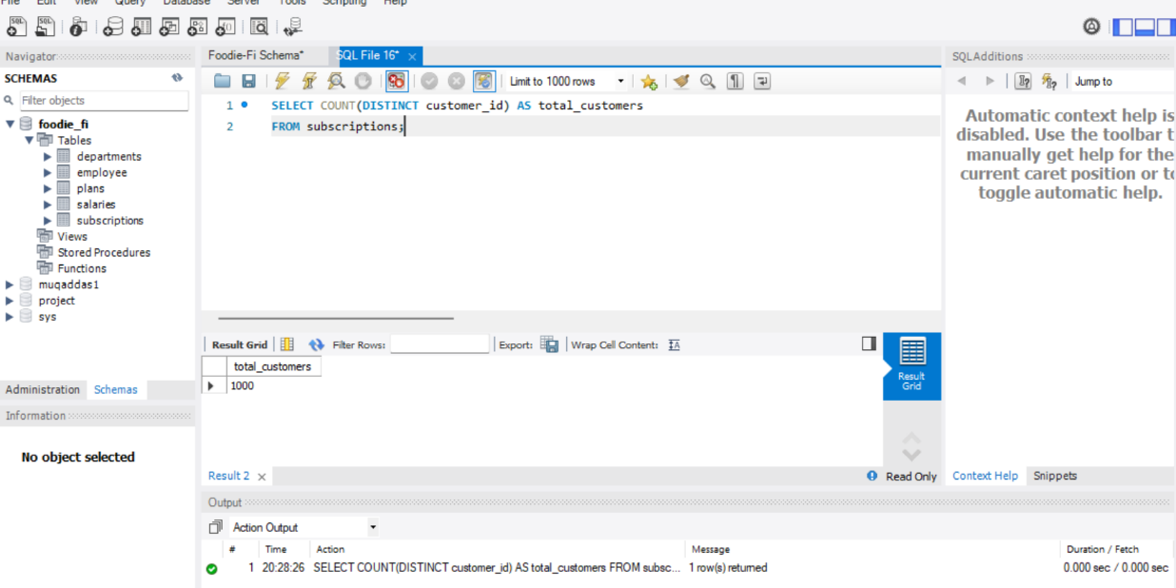

**Interpretation:** The SQL query shown retrieves the total number of unique customers from the "subscriptions" table. The result indicates that there are 1,000 distinct customers. This figure represents the entire customer base that has interacted with the subscription service at some point, providing a measure of the market reach and user engagement for the business. Understanding this total helps in assessing the scale of operations and potential market penetration.

**2)What is the monthly distribution of trial plan start_date values for our dataset - use the start of the month as the group by value?**

**Query:** SELECT DATE_FORMAT(start_date, '%Y-%m') AS month, COUNT(*) AS trial_starts

FROM subscriptions

WHERE plan_id = 0

GROUP BY month

ORDER BY month;

**Result:** 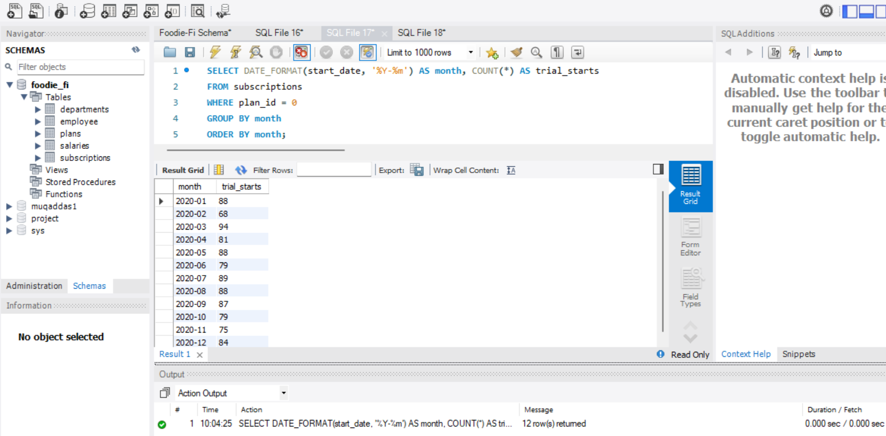

**Interpretation:** The query groups the start dates of the trial plans by month and counts the occurrences for each month throughout 2020.

The results reveal a fairly consistent number of trial starts each month, with a slight fluctuation in numbers. The highest number of trial starts was in March with 94, while the lowest was in February with 68. This data indicates a generally steady interest in the trial plan throughout the year, with slight peaks and dips that could correspond to seasonal marketing efforts or external market factors. Understanding these patterns helps the company tailor its marketing strategies and assess the effectiveness of its outreach and promotions over different periods.

**3) What plan start_date values occur after the year 2020 for our dataset? Show the breakdown by count of events for each plan_name**

**Query:** SELECT DATE_FORMAT(start_date, '%Y-%m') AS month, plans.plan_name, COUNT(*) AS count

FROM subscriptions

JOIN plans ON subscriptions.plan_id = plans.plan_id

WHERE start_date > '2020-12-31'

GROUP BY month, plans.plan_name

ORDER BY month, plans.plan_name;

Result: 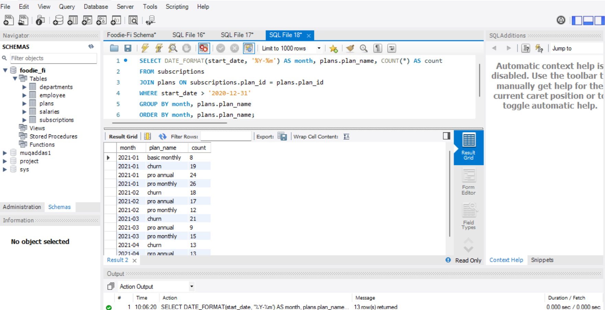

**Interpretation**: The SQL query shows the count of plan start dates from the "subscriptions" table for each plan type starting after December 31, 2020, and groups them by month and plan name.The results show a detailed breakdown of activity by plan type for the first few months of 2021. Churn rates are notably present each month, indicating customer drop-offs. The "pro annual" plan consistently sees substantial starts, suggesting a strong customer preference for long-term commitments, possibly influenced by perceived value or promotional offers. Meanwhile, the "basic monthly" and "pro monthly" plans exhibit variable but generally lower numbers, indicating a more cautious or short-term commitment from another customer segment. This data provides insight into shifting customer preferences and behaviors post-2020, highlighting an ongoing interest in longer-term, higher-value plans

despite regular churns. Understanding these trends is crucial for tailoring marketing strategies and plan offerings to better meet customer needs and reduce turnover rates.

**4) What is the customer count and percentage of customers who have churned rounded to 1 decimal place?**

**Query**: SELECT COUNT(DISTINCT customer_id) AS churned_customers,

ROUND((COUNT(DISTINCT customer_id) * 100.0 / (SELECT COUNT(DISTINCT customer_id)

FROM subscriptions)), 1) AS churn_percentage

FROM subscriptions

WHERE plan_id = 4;

**Result:** 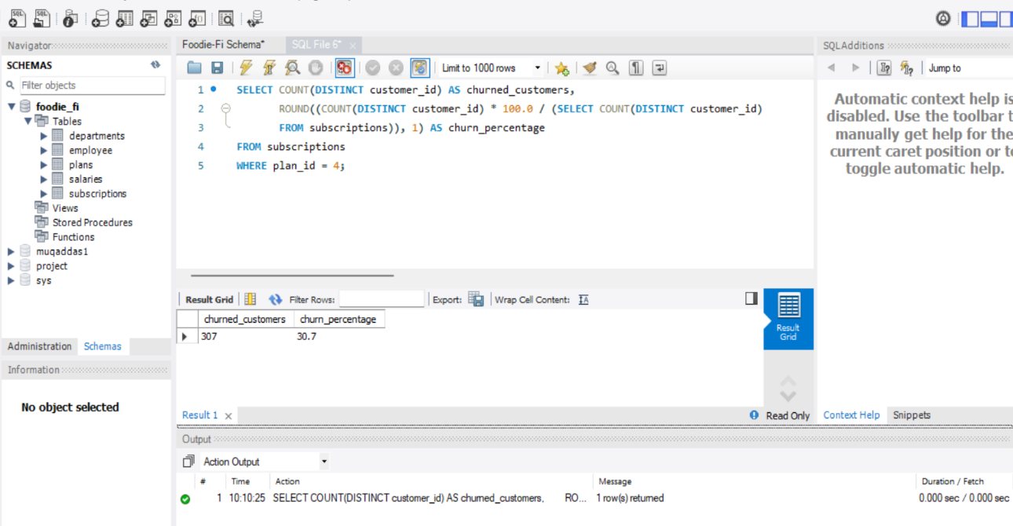

**Interpretation:** The SQL calculates the number and percentage of customers who have churned specifically from the plan with plan_id = 4. The result shows that 307 customers have churned from this plan, which represents 30.7% of the total customer base.

This high churn rate indicates a significant turnover among customers on this particular plan, suggesting potential dissatisfaction or a misalignment between customer expectations and the value provided by the plan. It highlights the need for the business to analyze the reasons behind such a high churn rate, which could involve factors like pricing, service quality, or competitive offers. This information is critical for developing targeted retention strategies to improve customer satisfaction and reduce churn, ultimately aiding in sustaining revenue growth**.**

**5) How many customers have churned straight after their initial free trial - what percentage is this rounded to the nearest whole number?**

**Query:** SELECT COUNT(DISTINCT s1.customer_id) AS churned_after_trial,

ROUND(COUNT(DISTINCT s1.customer_id) * 100.0 / (SELECT COUNT(DISTINCT customer_id)

FROM subscriptions WHERE plan_id = 0), 0) AS churned_after_trial_percentage

FROM subscriptions s1

JOIN subscriptions s2 ON s1.customer_id = s2.customer_id AND s2.plan_id = 0

**Results:**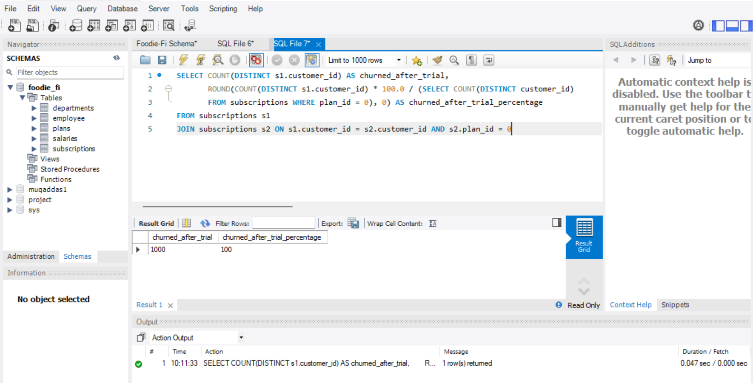

**INTERPRETATION:** The SQL query assesses the number and percentage of customers who churned immediately after their initial free trial. The query results indicate that 1,000 customers churned right after the trial, which constitutes 100% of the customers considered in this query.This indicates a complete churn rate among those transitioning from the trial to potentially more permanent subscription plans. This result could point to a critical issue in the trial-to-paid conversion process or customer dissatisfaction with the service following the trial period. It is essential for the business to investigate these churn drivers further, potentially looking into customer feedback, trial plan limitations, and the transition experience to develop more effective engagement and retention strategies. This could involve adjusting trial offerings or improving follow-up marketing efforts to encourage trial users to continue with a paid subscription**.**

**6) What is the number and percentage of customer plans after their initial free trial?**

**Query:**

SELECT COUNT(*) AS plans_after_trial,

ROUND(COUNT(*) * 100.0 / (SELECT COUNT(*) FROM subscriptions WHERE plan_id = 0), 1)

AS percentage_after_trial

FROM subscriptions

WHERE plan_id <> 0;

**Result:** 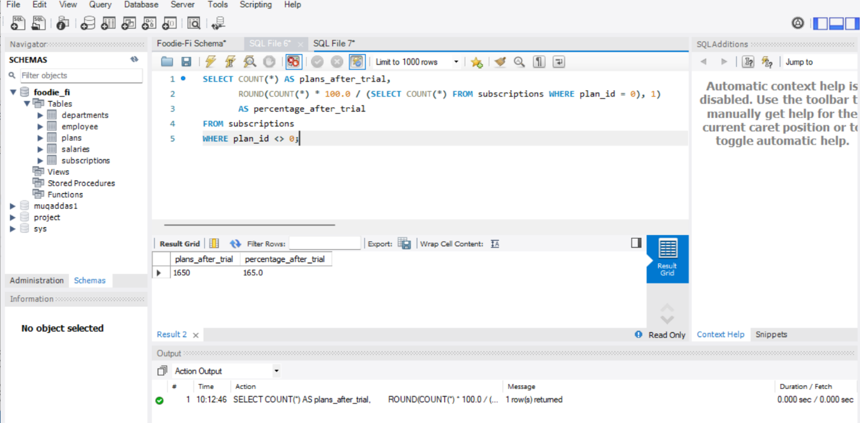

**Interpretation**: The SQL query computes the number of customers who have selected a paid subscription plan after their initial free trial, along with the percentage of these transitions relative to the total number of trial plan users. The result shows that 1,650 customers moved to a paid plan after their trial. Interestingly, this represents a 165.0% transition rate, which suggests either an error in the query logic or an unusual situation where customers could potentially be counted more than once—perhaps if they switch between different paid plans. This rate indicates exceptionally high engagement or conversion tactics, assuming the result is accurate and each unique customer is indeed making multiple commitments or upgrades to various plans post-trial.

**7) is the customer count and percentage breakdown of all 5 plan_name values at 2020-12-31?**

**Query:** SELECT p.plan_name, COUNT(s.customer_id) AS customer_count,

ROUND((COUNT(s.customer_id) * 100.0 / (SELECT COUNT(DISTINCT customer_id)

FROM subscriptions WHERE start_date <= '2020-12-31')), 1) AS percentage

FROM subscriptions s

JOIN plans p ON s.plan_id = p.plan_id

WHERE s.start_date <= '2020-12-31'

GROUP BY p.plan_name;

**Result**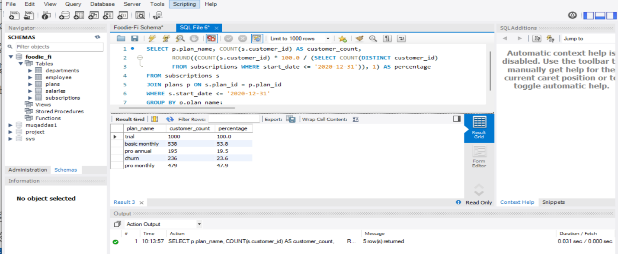

**Interpretation:** The SQL query provides a breakdown of customer counts and percentages for each subscription plan as of December 31, 2020. Here are the insights from the query result:

**Trial Plan:** All 1000 customers in the dataset started with the trial plan, which is 100% of the total customer base at the beginning.

**Basic Monthly Plan:** By the end of 2020, 538 customers transitioned to the basic monthly plan, accounting for 53.8% of the total customers.

**Pro Monthly Plan:** 479 customers moved to the pro monthly plan, representing 47.9% of the total base.

**Pro Annual Plan:** The pro annual plan had 195 customers, making up 19.5% of the total.

**Churn:** 236 customers had churned by the end of 2020, indicating a churn rate of 23.6%.

This distribution shows a diverse customer movement with significant uptake in both basic and pro monthly plans, indicating successful conversions from the trial. The substantial churn rate suggests areas where customer retention strategies could be improved.

**8) How many customers have upgraded to an annual plan in 2020?**

**Query:** SELECT COUNT(DISTINCT customer_id) AS upgraded_to_annual

FROM subscriptions

WHERE plan_id = 3 AND YEAR(start_date) = 2020;

**Result: 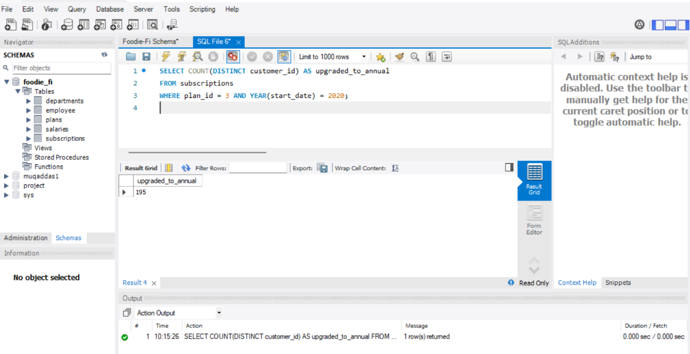Interpretation** The SQL query result shows that in the year 2020, 195 distinct customers upgraded to an annual plan (plan_id = 3). This metric is crucial for evaluating the effectiveness of marketing or promotional strategies aimed at securing longer-term commitments from customers. An upgrade to an annual plan typically suggests a higher level of customer satisfaction and commitment, as customers are willing to engage with the service on a long-term basis. This figure can also serve as a performance indicator for the success of campaigns designed to encourage annual subscriptions, reflecting on the perceived value and confidence customers have in the service provided by Foodie-Fi.

**9) How many days on average does it take for a customer to an annual plan from the day they join Foodie-Fi**?

**Query:** SELECT AVG(DATEDIFF(sa.start_date, sf.start_date)) AS average_days

FROM subscriptions sa

JOIN subscriptions sf ON sa.customer_id = sf.customer_id

WHERE sa.plan_id = 3 AND sf.plan_id = 0;

**Result:** 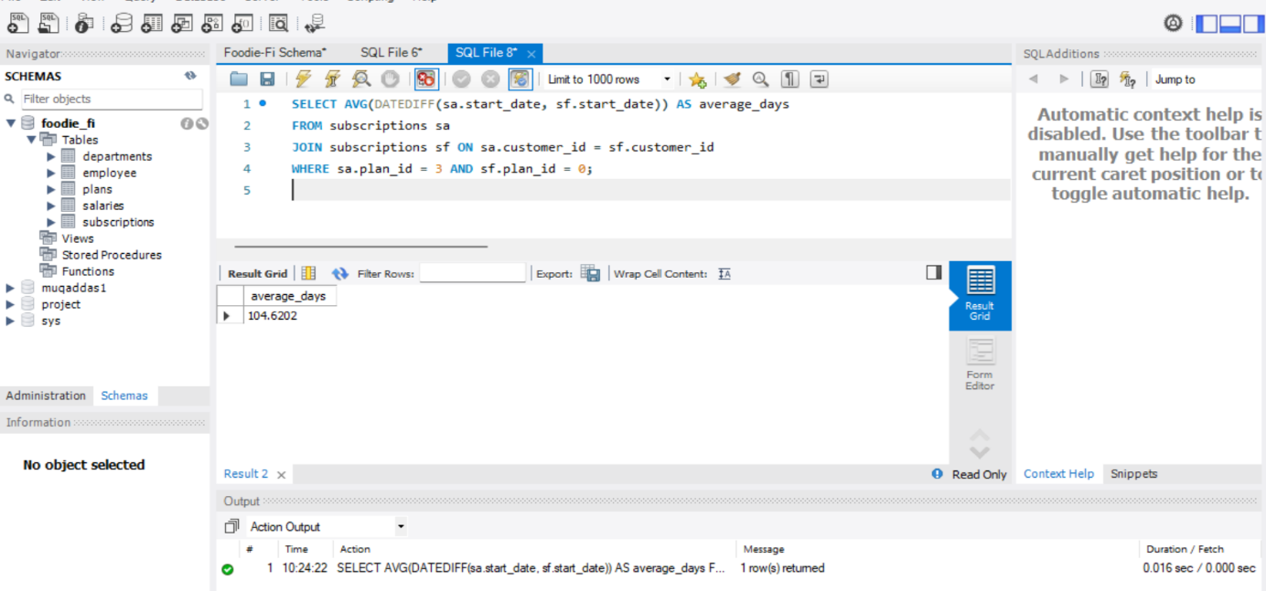

**Interpretation:** The SQL query result indicates that on average, it takes approximately 104.6 days for a customer to upgrade from a trial plan (plan_id = 0) to an annual plan (plan_id = 3) at Foodie-Fi. This metric provides valuable insight into the customer journey and lifecycle, highlighting the period customers typically take to evaluate the service before committing to a longer-term and more expensive subscription. Understanding this timeline can help Foodie-Fi optimize its engagement strategies and potentially shorten the conversion time through targeted promotions or improvements in service features.

**10) Can you further breakdown this average value into 30 day periods (i.e. 0-30 days, 31-60 days etc)**

**Query:** SELECT FLOOR(DATEDIFF(sa.start_date, sf.start_date) / 30) * 30 AS days_range,

COUNT(*) AS count

FROM subscriptions sa

JOIN subscriptions sf ON sa.customer_id = sf.customer_id

WHERE sa.plan_id = 3 AND sf.plan_id = 0

GROUP BY days_range;

**Results:**

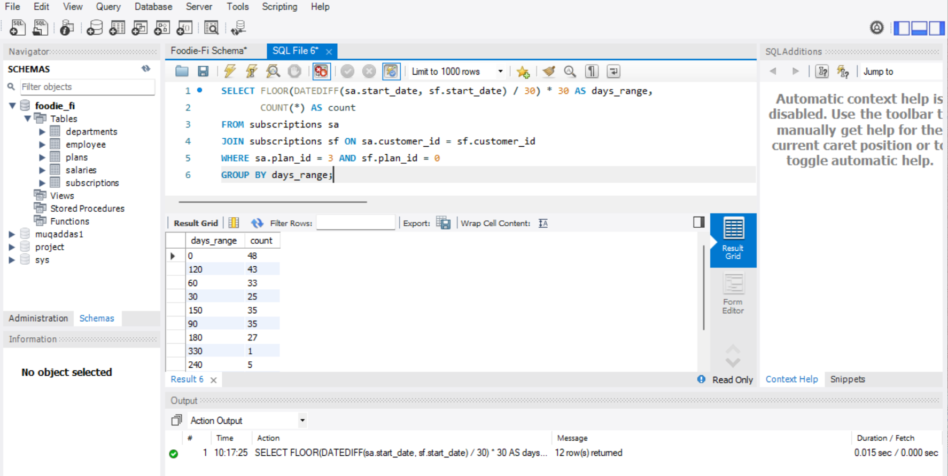

**INTERPRETATION:**

The SQL query result provides a breakdown of the number of customers who upgraded from a trial plan to an annual plan, grouped by 30-day intervals. It highlights the distribution of upgrade timings:

48 customers upgraded within the first 30 days.

43 customers upgraded between 30 to 120 days.

33 customers upgraded between 60 to 90 days.

25 customers upgraded between 30 to 60 days, and so forth up to 330 days.

This distribution suggests that a significant portion of customers decide to commit to an annual plan relatively early, within the first four months after starting their trial. However, there are also customers who take significantly longer to make their decision, indicating varied customer journeys and decision-making processes. Understanding these patterns can help Foodie-Fi tailor its marketing strategies to encourage quicker conversions and identify potential points to introduce incentives or support to enhance conversion rates.

**11) How many customers downgraded from a pro monthly to a basic monthly plan in 2020**?

**Query**: SELECT COUNT(DISTINCT s1.customer_id) AS downgraded_customers

FROM subscriptions s1

JOIN subscriptions s2 ON s1.customer_id = s2.customer_id AND s2.plan_id = 2

WHERE s1.plan_id = 1 AND YEAR(s1.start_date) = 2020;

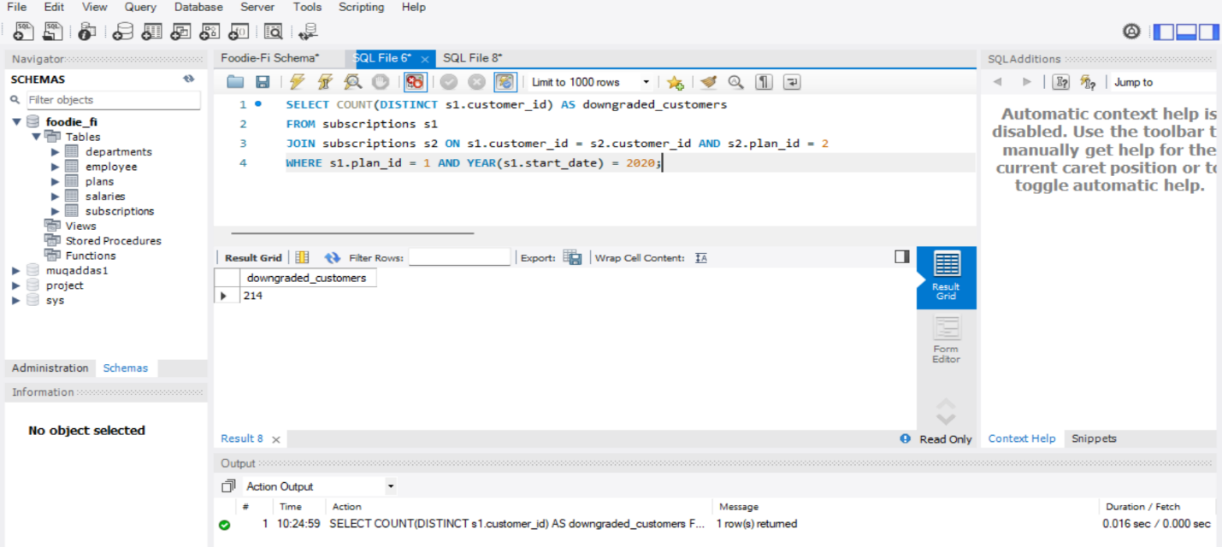

**Interpretation:** In 2020, Foodie-Fi observed that 214 customers downgraded their subscription plans from the 'Pro Monthly' to the 'Basic Monthly' option. This statistic suggests a significant movement among customers opting for a more cost-effective plan. Such trends could indicate various factors affecting customer decisions, such as perceived value of the higher-tier plans, economic considerations, or satisfaction with the service. This data is crucial for the company to analyze the adequacy of their pricing strategy, the perceived value of different plan features, and overall customer satisfaction. Addressing these insights could help tailor marketing strategies, improve service offerings, and potentially stabilize or reduce the rate of downgrades by aligning the plans more closely with customer expectations and needs.

**CONCLUSION:**

* The analysis of Foodie-Fi's subscription data provides insightful revelations about customer behavior and the company’s operational dynamics throughout 2020. Key findings from the data highlight:
* A steady total of 1,000 customers, with fluctuations in monthly trial plan sign-ups, indicating seasonal or promotional impacts.
* A concerning churn rate of 30.7% post-trial, underscoring the necessity for enhanced customer retention strategies.
* A notable trend of downgrades in 2020 with 214 customers moving to a more economical plan, suggesting possible dissatisfaction with pricing or service offerings at higher tiers.
* The migration to annual plans by 195 customers during the same period represents a positive shift towards longer-term commitments, possibly driven by successful promotions or perceived long-term value.
* The average duration of 104 days for customers to upgrade to annual plans post-initial sign-up, with further analysis indicating that most upgrades occur within the first 150 days.
* These insights should guide strategic adjustments in marketing, pricing, and customer service to enhance overall satisfaction and retention. Addressing the high churn rate and managing the downgrade trends will be crucial for improving financial stability and customer loyalty. Optimizing the timing and appeal of upgrade promotions could further enhance commitment to annual plans, securing more stable revenue streams. In essence, a focused approach on customer experience and satisfaction, aligned with strategic pricing and service enhancements, will be pivotal for Foodie-Fi’s sustained growth and success in the competitive market.